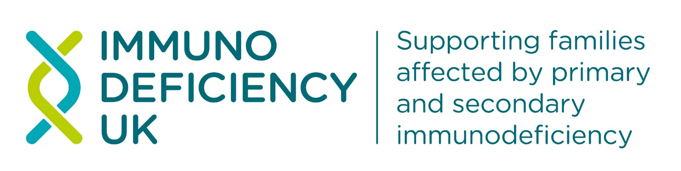
Digital Communications and Fundraising Officer
Location: Remote / Home-based
Hours: 14 hours per week over two working days within normal office hours
Hourly rate: £22 per hour on a freelance basis
Contract type: Freelance
Reports to: Chief Executive Officer
About Immunodeficiency UK
Immunodeficiency UK is a national charity providing advice and support for patients and families affected by primary or secondary immunodeficiency. We advocate for patient needs in healthcare policy and delivery and provide a helpline, educational resources, and practical advice for living with immunodeficiency, helping patients navigate healthcare systems and maintain wellbeing.
You can find out more about our work at Our Charity - Immunodeficiency UK.
About the Role
We are seeking a creative, proactive, and results-driven Digital Communications and Fundraising Officer to lead the development and delivery of engaging digital communications and fundraising campaigns. This role will play a key part in raising Immunodeficiency UK’s profile and awareness of primary and secondary immunodeficiency, growing supporter engagement and generating income to support our mission.
The successful candidate will manage digital channels, create compelling content including impact stories, support fundraising initiatives, analyse campaign performance, and build strong relationships with supporters, donors, and stakeholders.
Key Responsibilities
Digital Communications
- Develop and implement a digital communications strategy aligned with organisational objectives.
- Create, edit, and publish engaging content across websites, email marketing platforms, social media channels, and digital publications.
- Manage the organisation's website, ensuring content remains accurate, accessible, and up to date.
- Create and produce multimedia content including graphics, videos, photography, and case studies.
- Manage social media accounts and monthly newsletter content, increasing audience reach, engagement, and brand awareness.
- Monitor digital trends and recommend innovative approaches to improve communications performance.
- Track, analyse, and report on digital metrics using tools such as Google Analytics and social media insights.
Fundraising
- Plan and deliver digital fundraising campaigns to achieve income targets.
- Support donor acquisition, retention, and stewardship activities.
- Create compelling fundraising appeals and supporter communications.
- Manage online fundraising platforms and donation processes.
- Assist in developing fundraising materials, including campaign content and impact reports.
- Support fundraising events through promotion, participant engagement, and follow-up communications.
- Maintain accurate donor records and ensure compliance with data protection regulations.
- Identify opportunities to grow income through digital channels and supporter engagement.
- Provide administrative support to the CEO where needed.

Stakeholder Engagement
- Build and maintain positive relationships with donors, supporters, partners, and beneficiaries.
- Create content about the people we support, led by a storytelling approach with consistent tone and messages.
- Gather and share impact stories to demonstrate the value of supporter contributions.
Person Specification
Essential Skills and Experience
- Experience in digital communications, marketing, fundraising, or a related role.
- Excellent written and verbal communication skills.
- Experience in managing social media channels and creating digital content.
- Knowledge of email marketing platforms and customer relationship management (CRM) systems.
- Experience in planning and delivering fundraising or marketing campaigns.
- Strong organisational and project management skills.
- Ability to analyse data and translate insights into actionable recommendations.
- Proficiency in Microsoft Office, WordPress, and digital communication tools.
- Comfortable using basic artificial intelligence (AI)-powered tools to refine content, analyse data and extract information from reports.
- Ability to work independently and manage multiple priorities.
Desirable Skills and Experience
- Experience within the charity, non-profit, or social impact sector.
- Graphic design and video editing skills.

Personal Attributes
- Organised, resilient and a good communicator with strong attention to detail.
- Creative and innovative thinker.
- Excellent interpersonal and relationship-building skills.
- Ability to work on your own initiative and identify new opportunities.
- Self-motivated and results oriented.
- Flexible and adaptable approach to work.
What this role will offer you
You will be part of a small but influential charity working to achieve better health outcomes for people with primary and secondary immunodeficiency. The role offers an opportunity to exercise your creativity on varied and interesting projects that can make a real difference to people’s lives. You will receive excellent support and encouragement from our CEO and Trustees.
Diversity and inclusion
Immunodeficiency UK is committed to equality, diversity and inclusion, and welcomes applications from all suitably qualified candidates regardless of age, disability, gender identity, marital status, race, religion or belief, sex, sexual orientation, or any other protected characteristic.
To apply, please submit your CV and a covering letter outlining how your skills and experience meet the role's requirements here. The deadline for applications is 4th of September.

